Product Name | Applied Degree in Software Engineering (BDSE)
Qualification Name | Applied Degree in Software Engineering
Product Name | Programming Foundations
Module Name (BDSE) | Programming Foundations

Learner name |  |  | Assessor name
VIDDY VIRSTANDI PARAMANAYAKA ANDANAWARI PURNAMA |  |  | Anandita Bose and Rahul Raghubansi
Date issued | Completion date |  |  |  | Submitted on
 | 12 June 2022 |  |  |  | 12 June 2022
Project title |  | Development of MCQ System

Plagiarism
Plagiarism covers both copying or paraphrasing with the source without proper understanding and citation. The source includes but is not limited to
• Books, Journal Articles, Online resources
• Others Assignment or project
• Software program
• Images

The learners must submit their work without plagiarism while producing the evidence against the assessment criteria. They must apply proper citation and Harvard referencing. Their work must go through the Turnitin software to check for the similarity index. Please consult the relevant module instructor or mentor if you need any further advice.

Learner declaration
I certify that the work submitted for this assignment is my own and research sources are fully acknowledged.
Student signature: Date: 12 June 2022

Table of Contents
1. Introduction 3
2. Background 3
3. Algorithm 3
4. Types of Algorithms 4
5. Coding Standards 9
6. Project Design 12
7. Implementation 13

Introduction
Computer programming (often shortened to programming) is a process that leads from an original formulation of a computing problem to executable computer programs. Programming involves activities such as analysis, developing understanding, generating algorithms, verification of requirements of algorithms including their correctness and resources consumption, and implementation (commonly referred to as coding) of algorithms in a target programming language.

Background
This project created as requirement for passing the Fundamental Programming Module. To see what I gain and how far I have improved.

Algorithm
Algorithm programming is a procedure or formula used for solving problem. An algorithm works by following a procedure made up of input. Once the computer has followed all the inputs it will see a result, also known as output.

ALGORITHM
MCQ Project
Set up the programming language object oriented based for example:
- Java
Set up the development environment for example:
- IntelliJ IDEA
Prepare 2 Topics for MCQ in svc file:
-Java basic, -Control Structure

Input: your name, your answer
Step1: ask to put your name
Step2: input the name in the space that’ve been provided
Step3: display the MCQ topics option from 1 or 2
Step4: input the choice number between 1 or 2
Step5: If user enter number outside the range, ask again to put number between 1 or 2
Step6: read the chosen MCQ topic from the csv file
Step7: display the question and ask for answer
Step8: input the “a/b/c/d” answer
Step9: if correct, show that you are correct and increment the correct
Step10: if wrong, show the correct answer and increment the wrong
Step12: calculate the grade by using percentage (%)
Step13: after the last question display the input name, how many correct and false answer, result grade and message grade of MCQ test
Step14: otherwise continue displaying question goes to step7
Expect Output: result grade of MCQ

Types of Algorithms
There are six fundamental types of algorithms

1. Recursive Algorithm
This recursive algorithm is a process calling itself to solved the problem. It works by creating smaller or simpler input to get the solution on how to solved that problem.

2. Divide and Conquer Algorithm
The Divide and Conquer Algorithm work by dividing the algorithm into separate parts. The first part split the problem into smaller problem of the same type. The other one is a collection of these smaller part to be solved as final solution.

3. Dynamic Programming Algorithm
The third one is Dynamic programming. These Algorithm works similar to Divide and Conquer except this algorithm solving problem by remember the last result of the run then breaking them into multiple subproblem to gain new result and stores them.

4. Greedy Algorithm
This algorithm method is by choosing locally solution where is the most optimal that leads to the global level. Through elimination of possible candidate to be solved.

5. Brute Force Algorithm
Like the name, Brute Force algorithm solved problems by searching all possible solution that may help or solved the problem. For example, you have a bottle of marble then you forgot how far you have count. Since you don’t remember, you solved it by counting again from 0.

6. Backtracking Algorithm
A simple way to explain this algorithm is you solved problem one by one at a time. If can’t find the solution, we set that aside and backtrack to find another problem to be solved

Coding Standards
Coding Standards is some kind of rules that being used by all programmers. Rules that united all kind of things related to programming. Because every people have their own style, without standards the program will be difficult to learn by other programmer and will be hard to maintain and debug.

Benefit of coding standards:
- Easy team integration
- Increased code quality efficiency and easy for maintaining
- Reduce code complexity
- Reduce development cost
Common aspect of codding standards:
1. Naming Conventions:
- Meaningful and understandable variables, classes, interface, method and constants
- use pascal case, upper case, lower case at the right ones
2. Source File
- should be understandable named and structured
3. Package and Import Statement
- first non-comment line of most Java source files is a package statement.
4. Classes and Function
- specifies how classes and function should behave

5. Commenting
- Beginning comment: should begin with a c-style comment, include the programmer(s), date, copyright notice and a brief description
- Block comment, Single line comment, Trailing comment
6. Indentation
- Line length, wrapping line, method declaration, format ternary operator
7. Declaration
- one declaration per line
- put only at the beginning of blocks
- Try to initialize local variables where they’re declared.

List of coding standard that I used
Naming convention
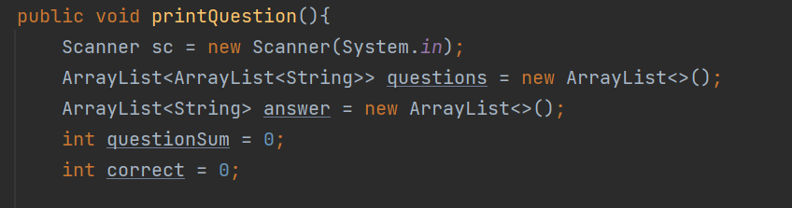
Method using mixed case and a verb importQuestion.
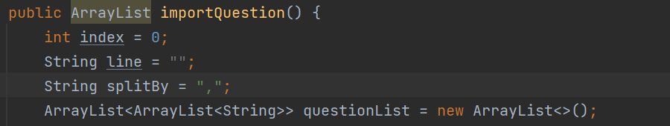

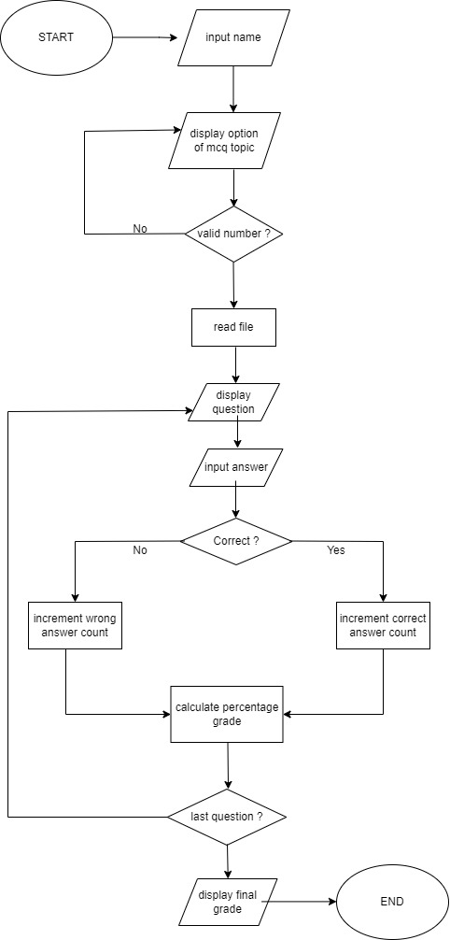
Project Design
yes
no

Implementation
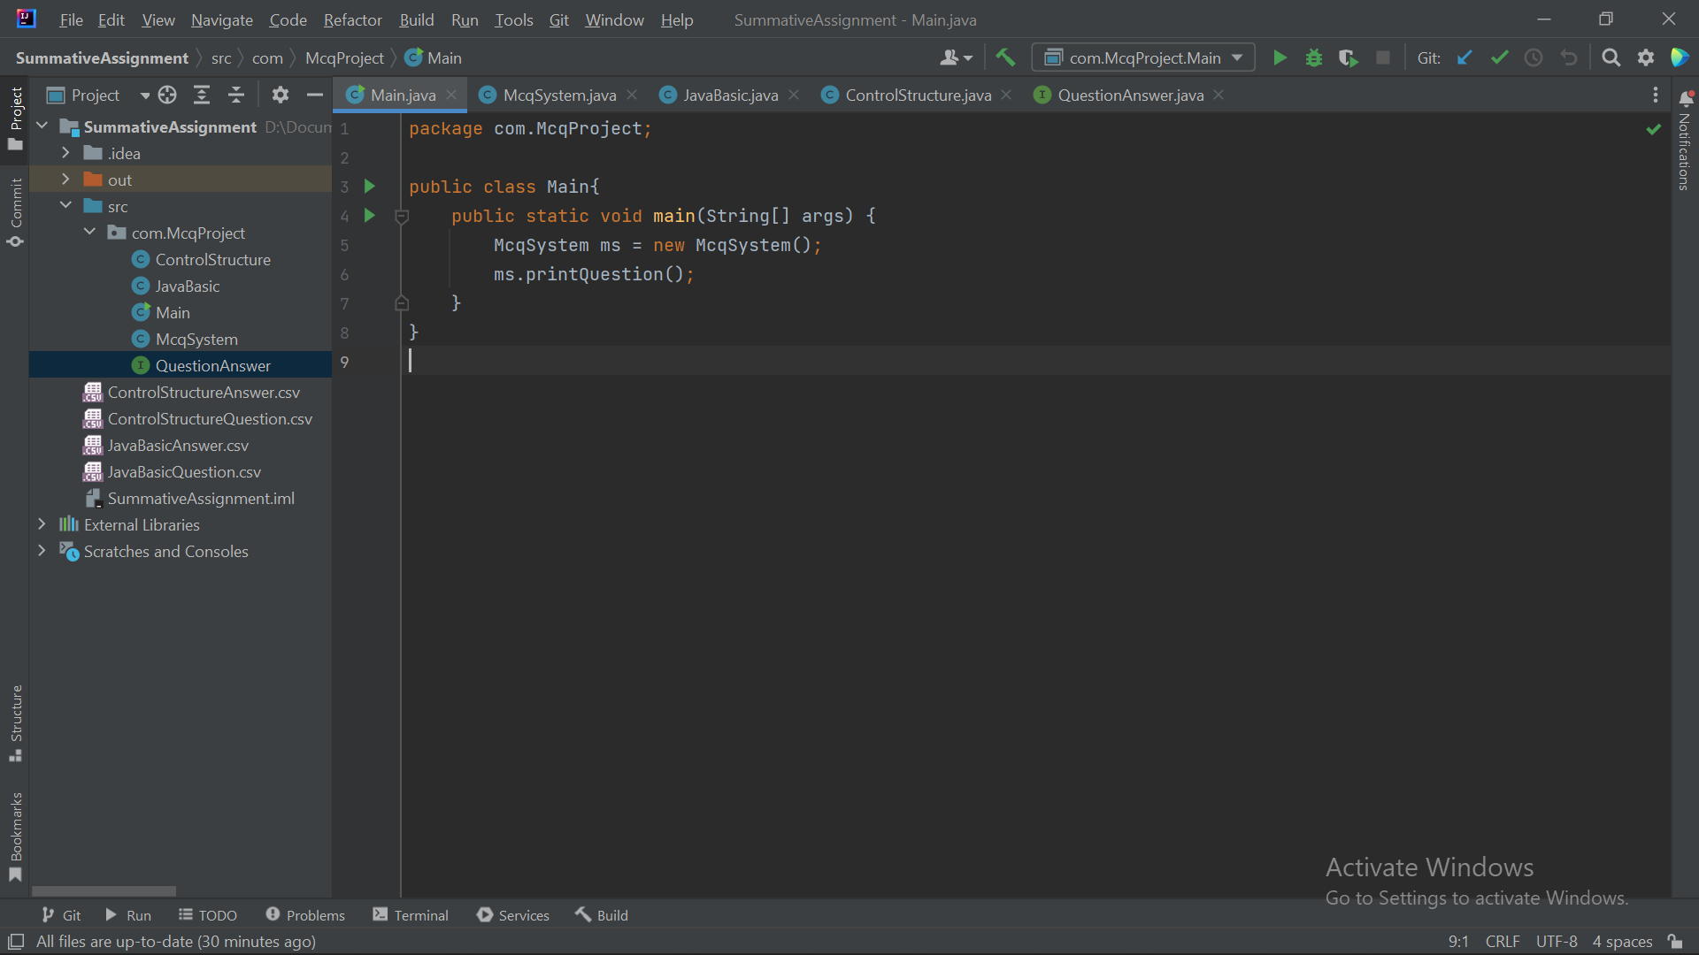
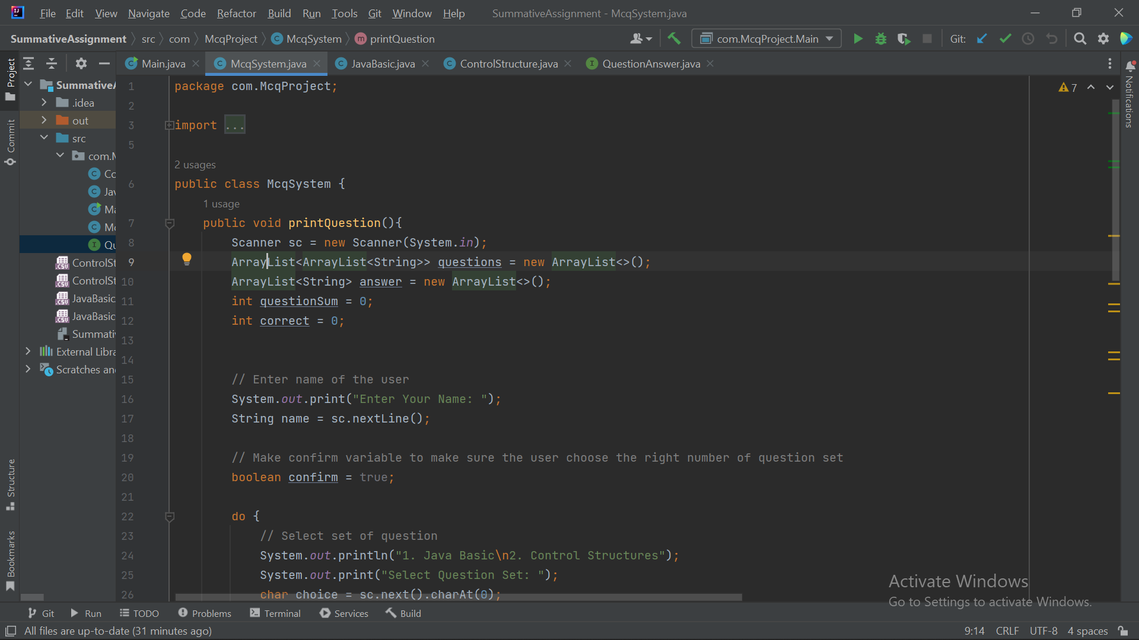
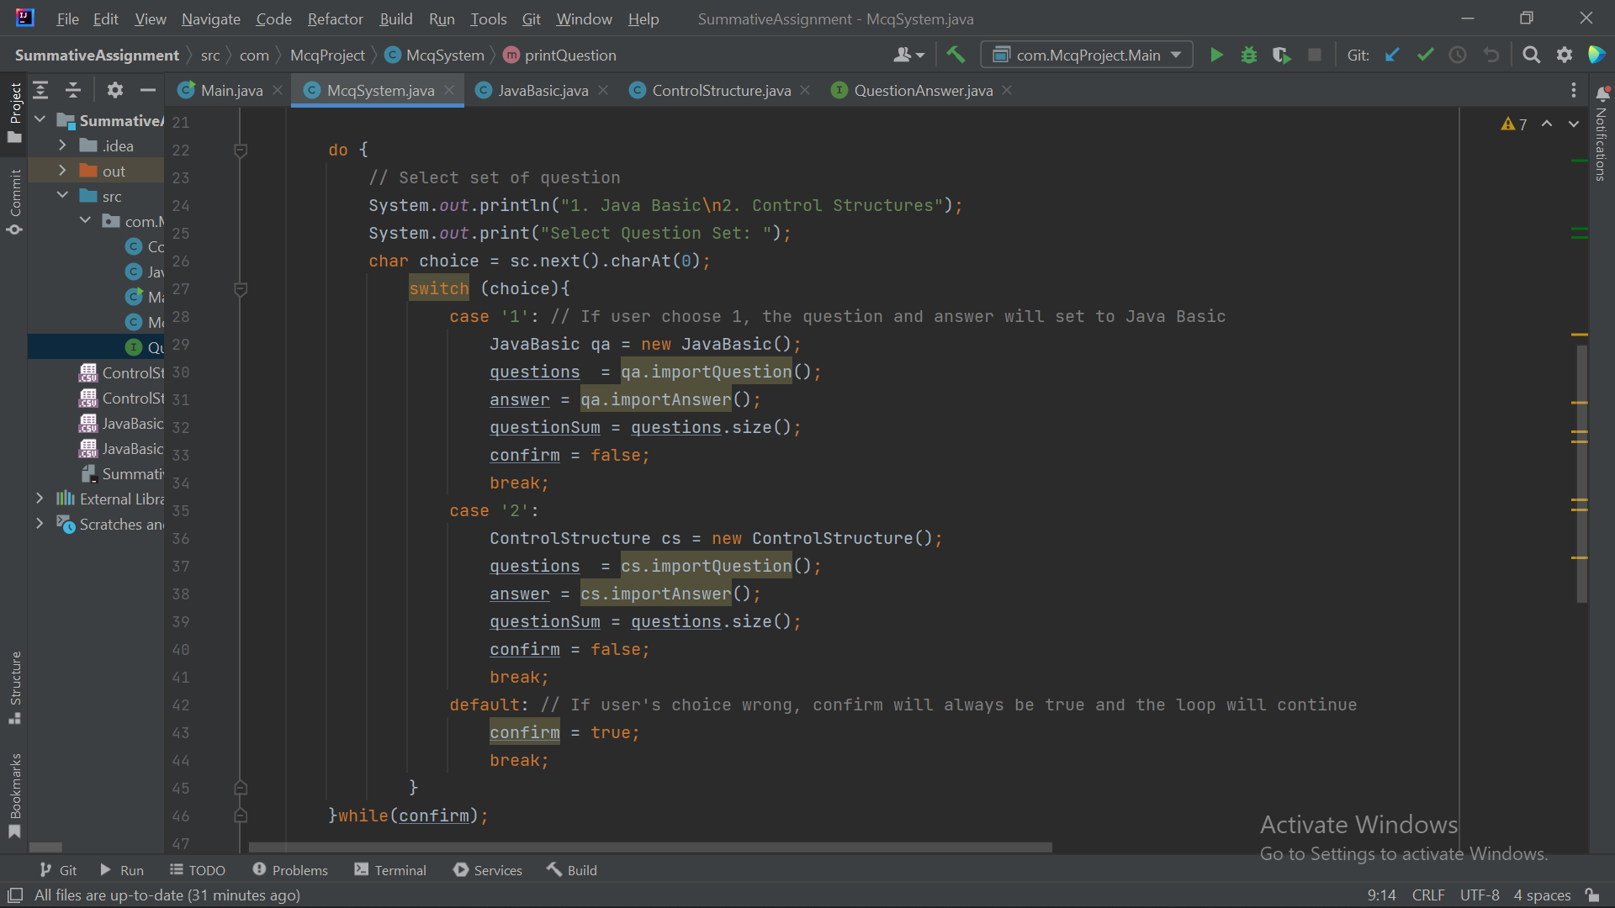
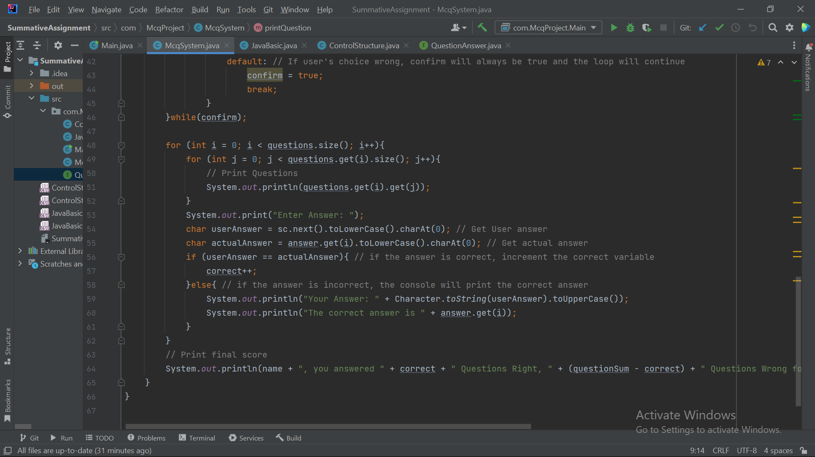
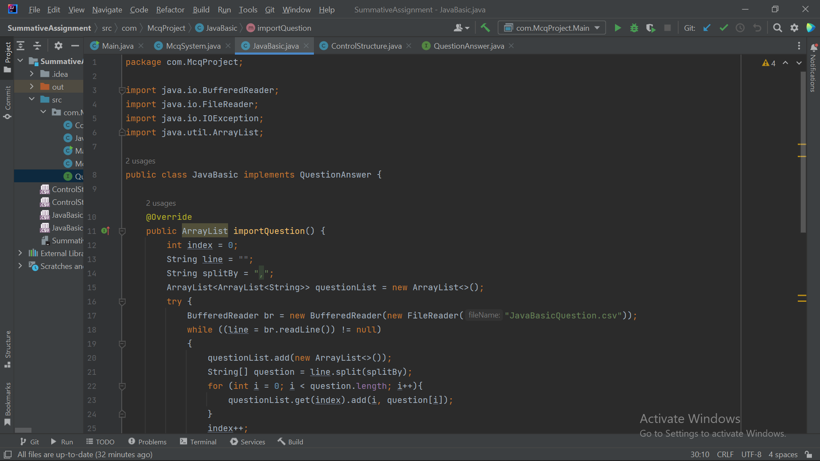
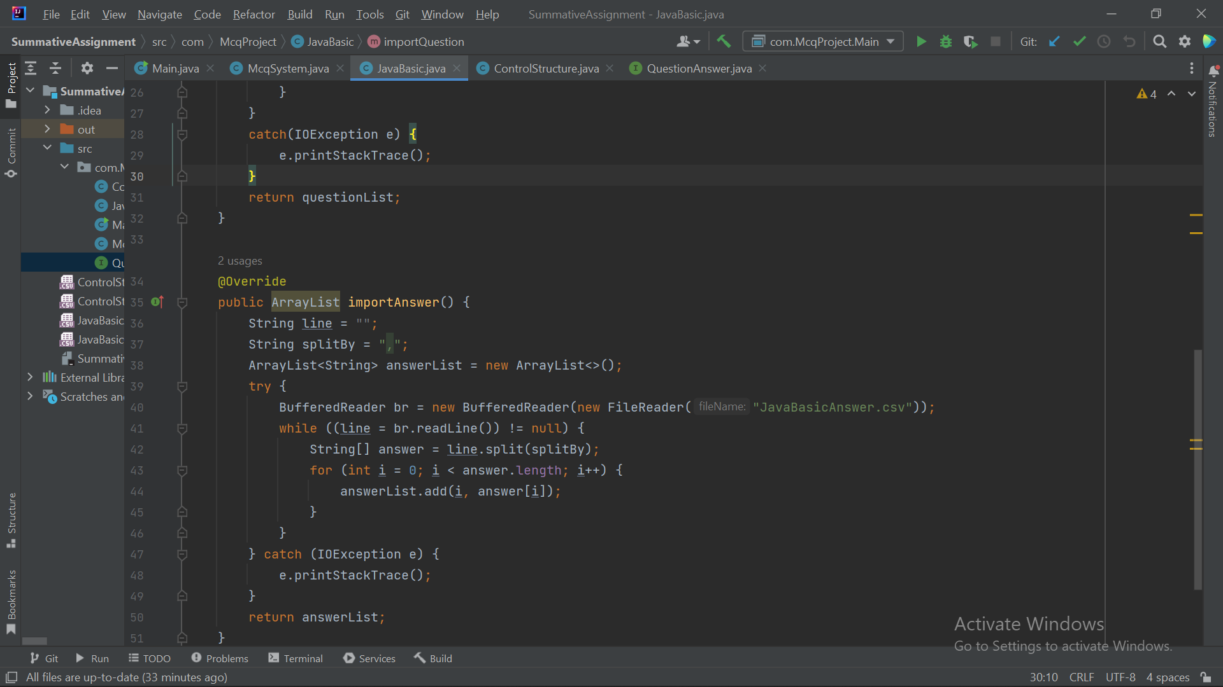
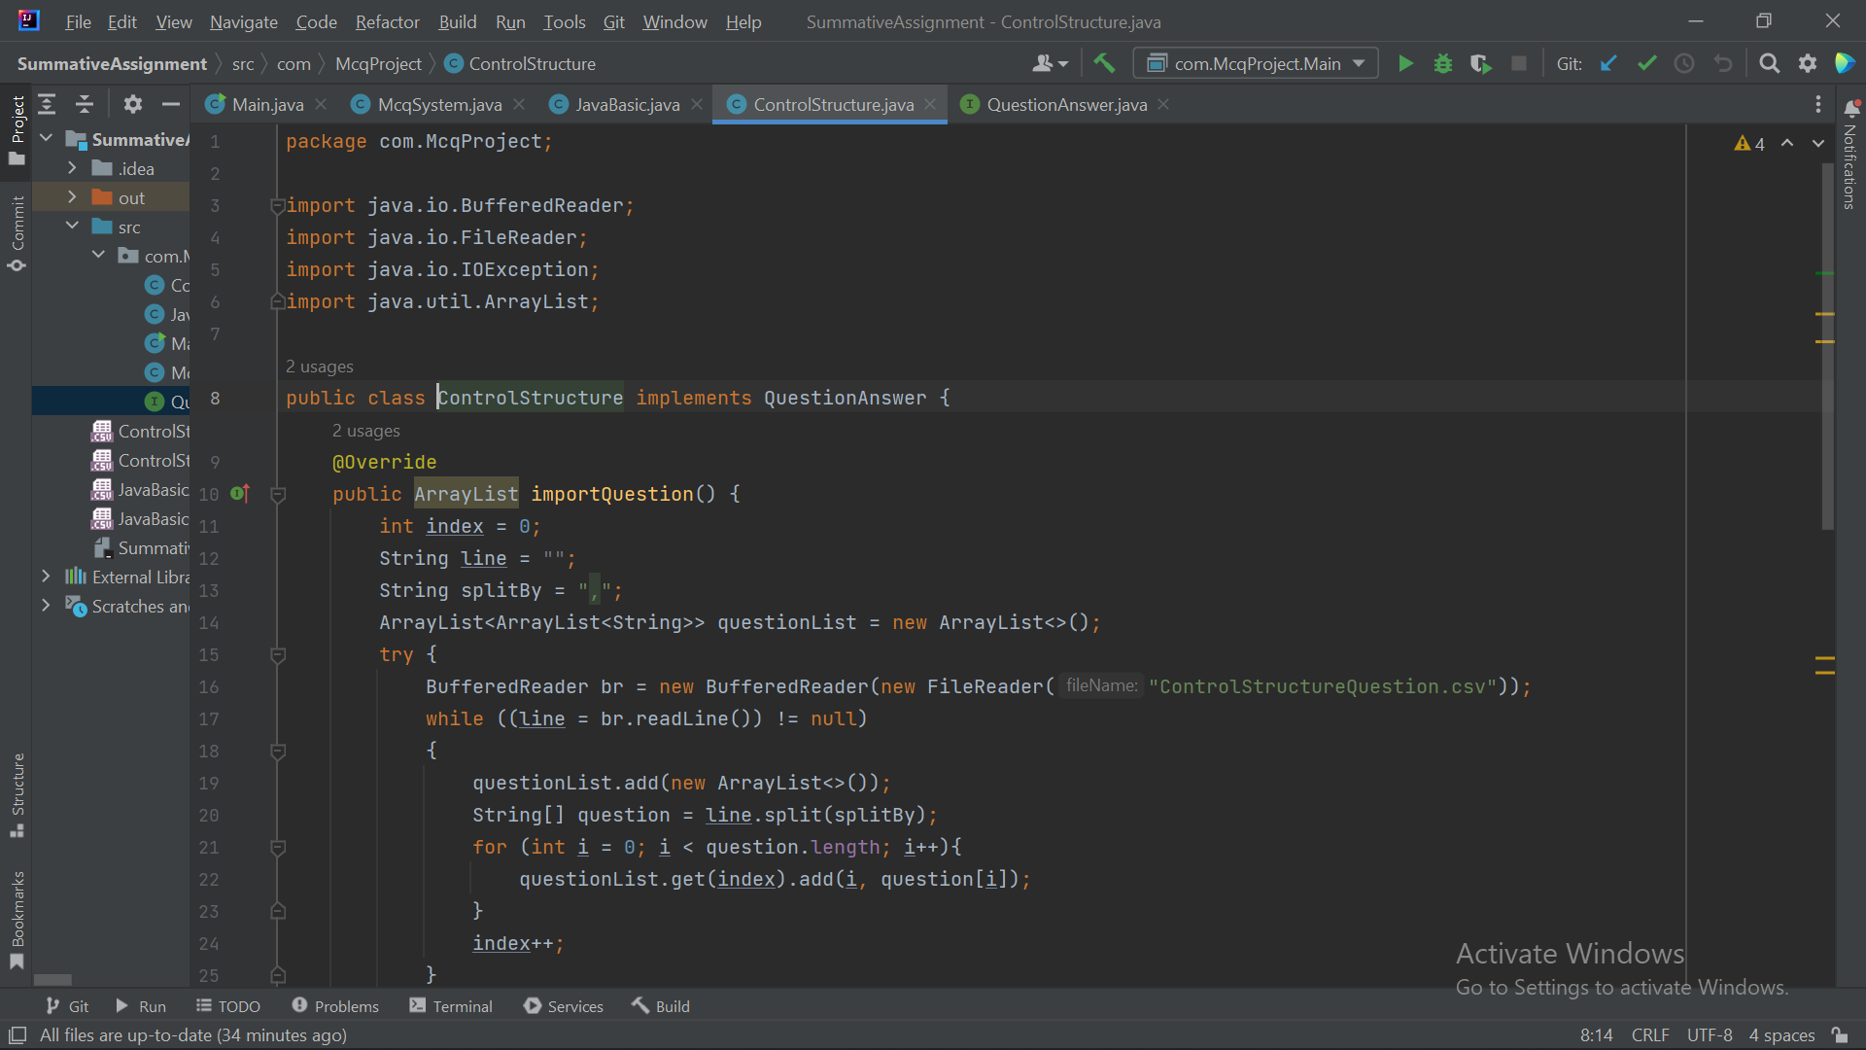
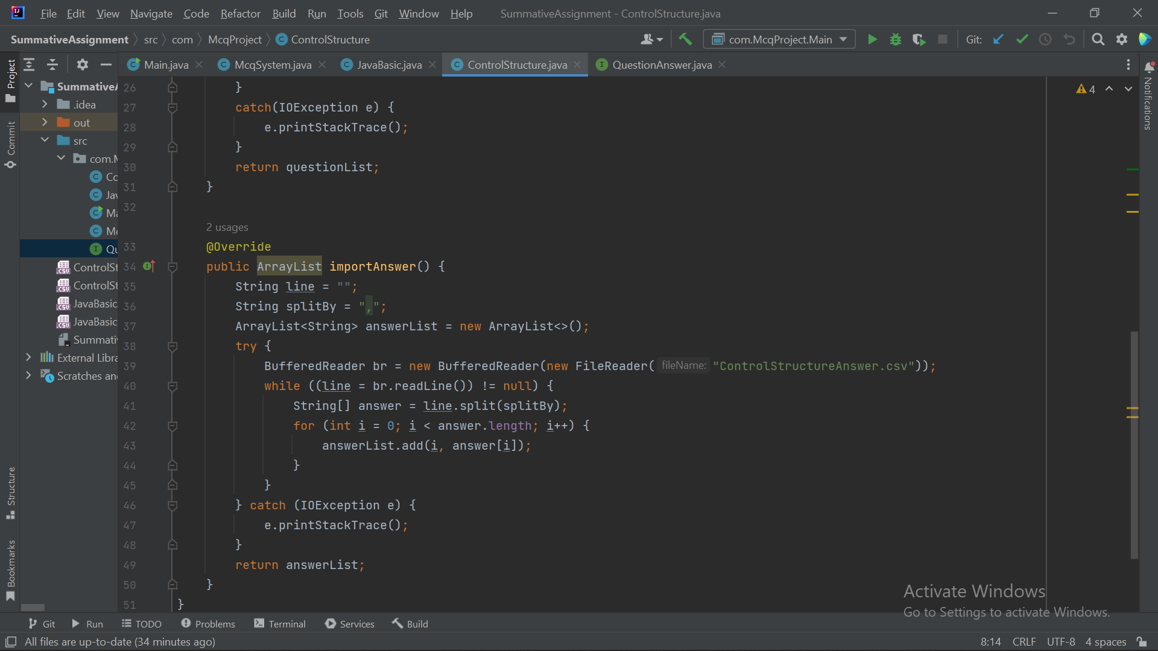
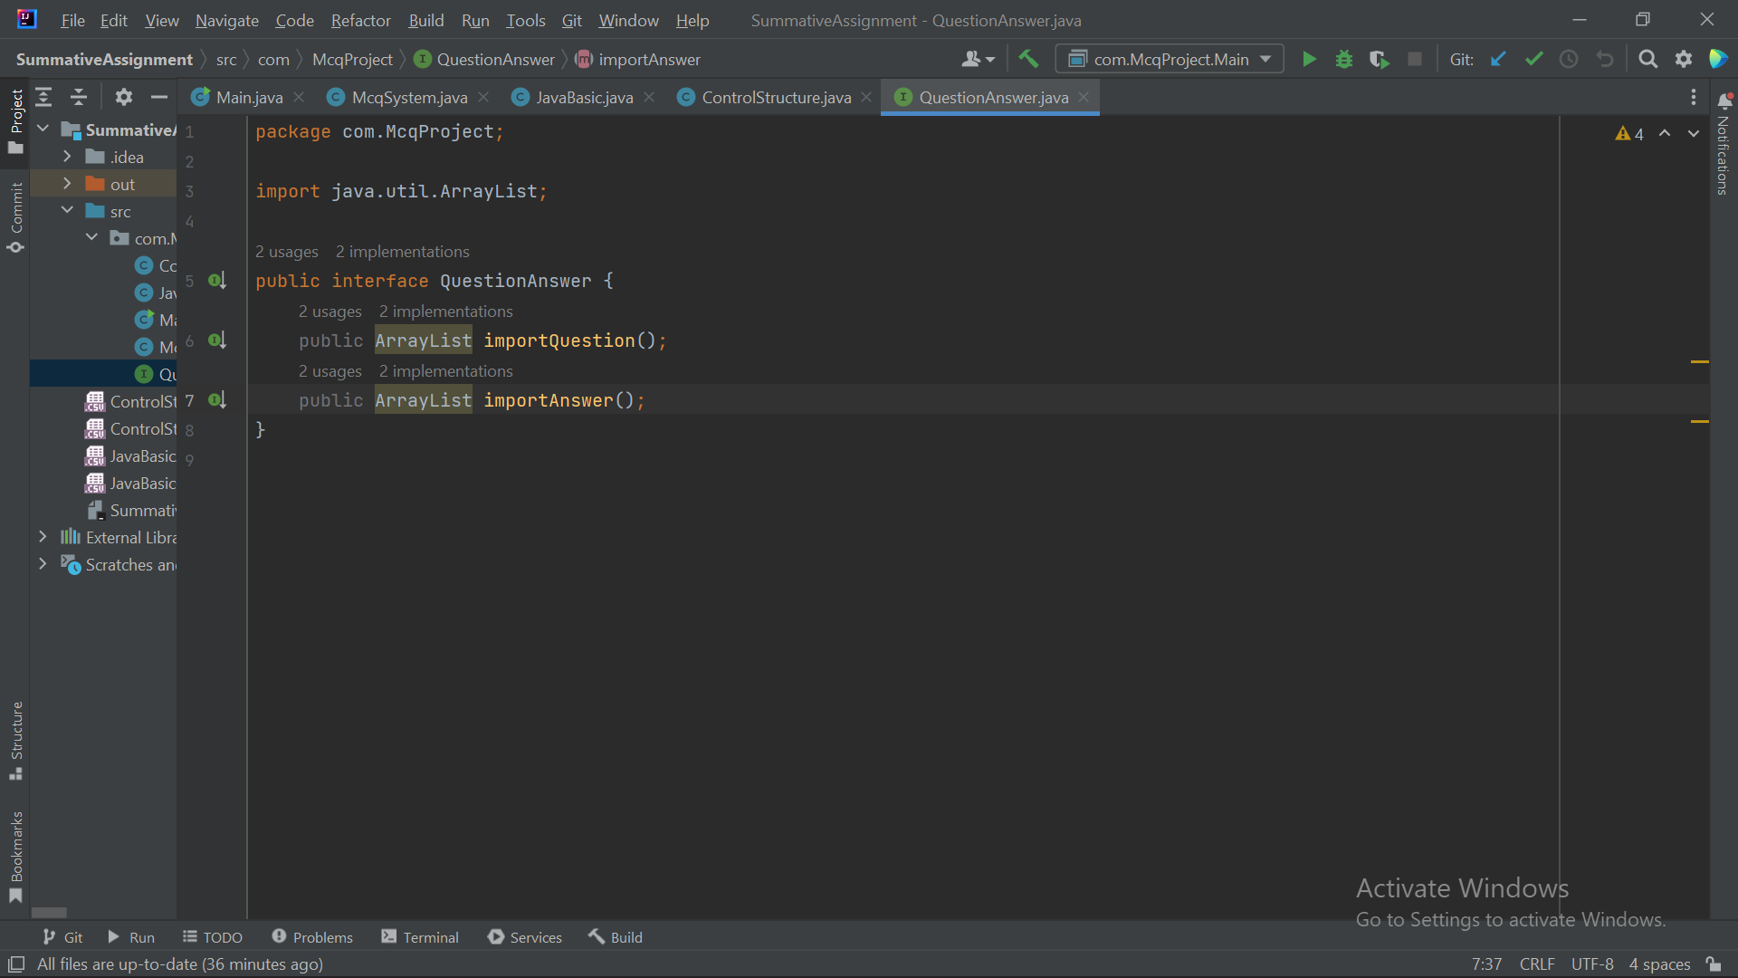

Brief explanation
- Asking name by creating class for the name, and call it in main app
- Displaying the option and ask to choose the MCQ topics using switch case while looping
- Create method to ask valid option MCQ topic and later also for to loop if want to take another MCQ or no
- Create class for declare field and getter setter for the object that later the question in the file will be print as String using toString method, and a method for display text if correct and wrong answer
- Create class for reading file level, inside is method to read file, read question line by line, ask for answer, counting on correct and wrong answer and giving grade for the result mcq
- A method to call the read file, get answer and result in the reading file level class
- Make separate class for each question to take the file by inherit the constructor from the reading file level class
- Call the method that has methods that has been read and also the result that has been graded in the choices of MCQ topics in main app

